Jenkins with multiple Git branches (TEST, Dev, Prod) and deploying to EC2 instances:

1.Setup 3 Private repos

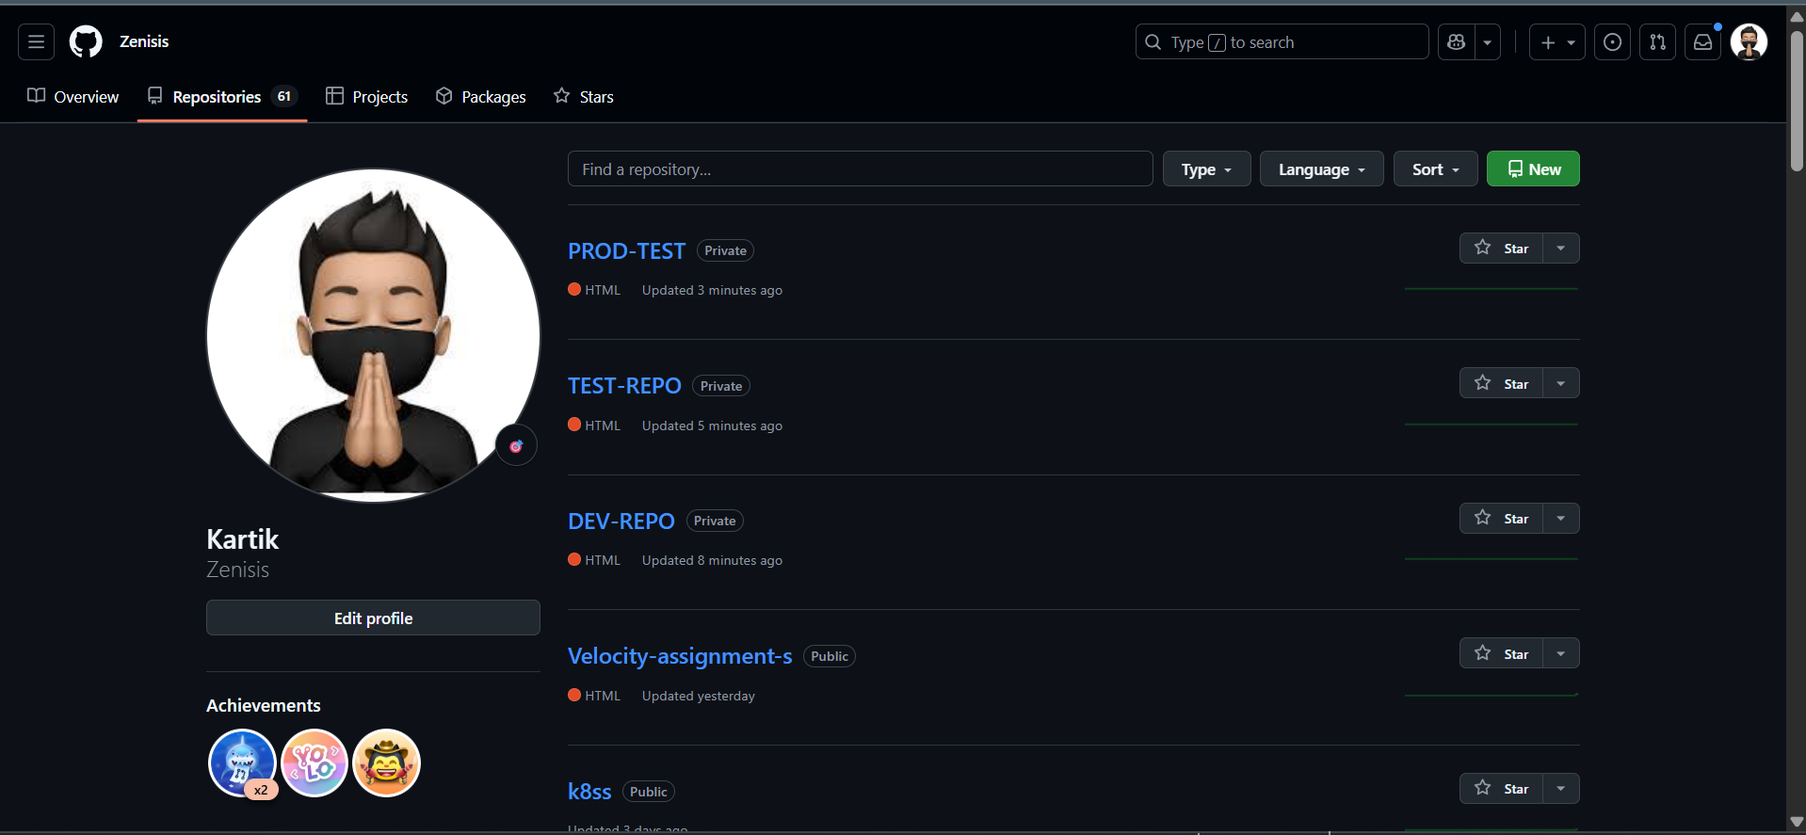

Create index.html file

In TEST-branch, PROD-branch, DEV-branch

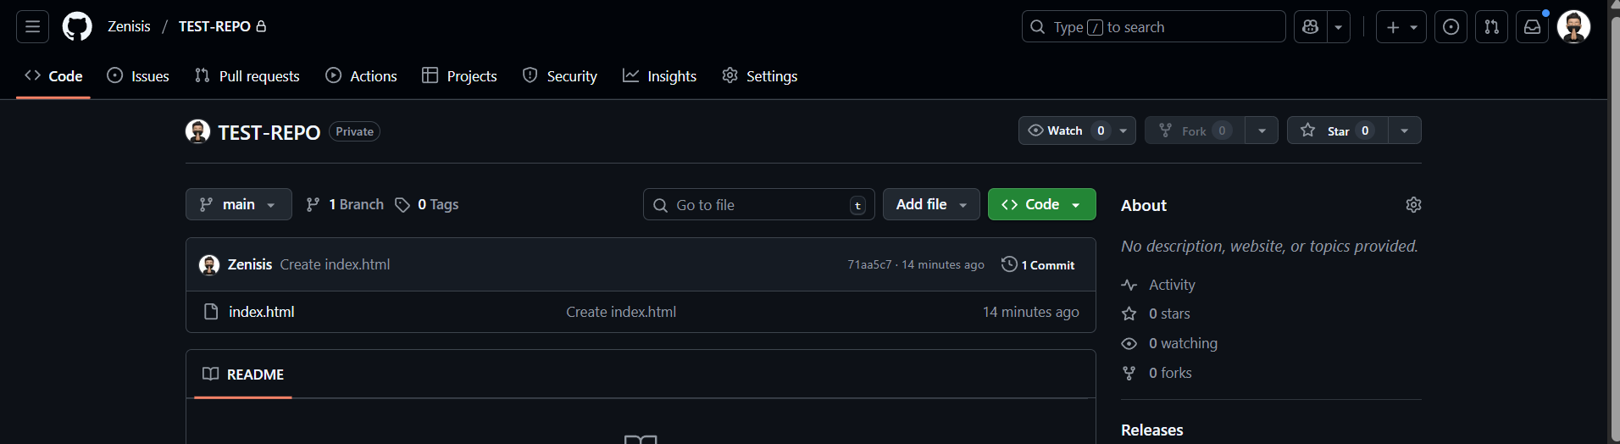

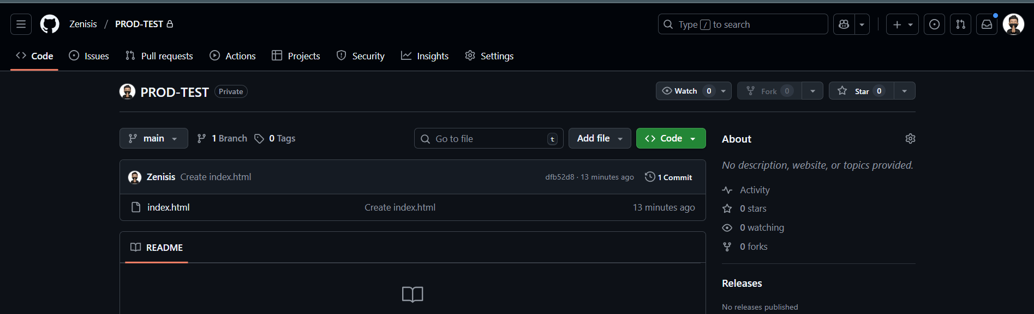

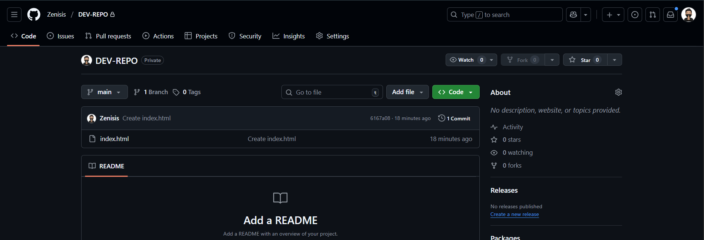

Step -2 Setup Jenkins on ec2 install jenkins and httpd server on that 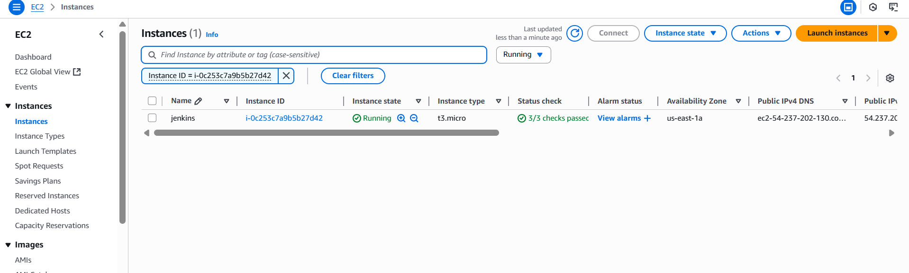

Step -3 Create jobs on jenkins dashboard for each

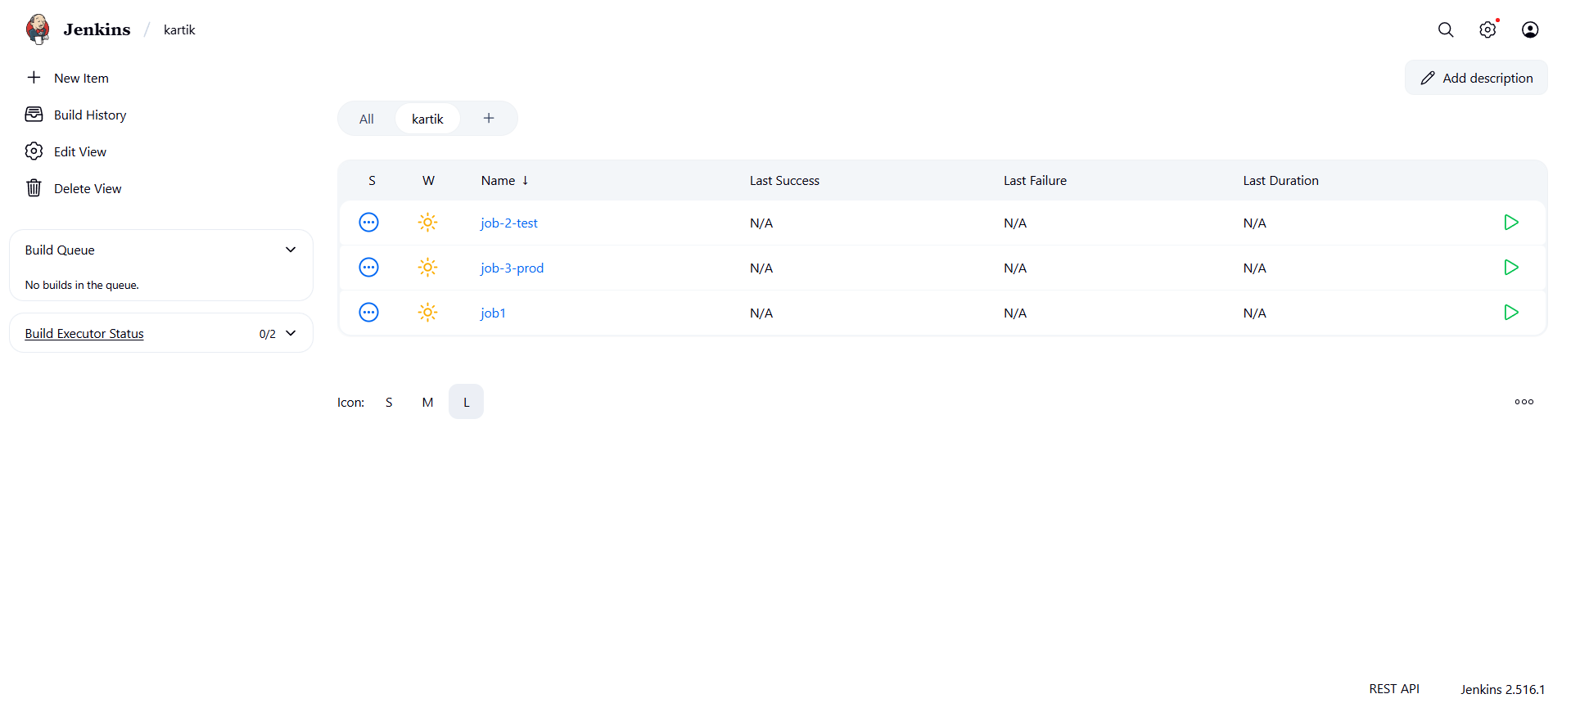

Step-4 configure the job set up the discard build and SCM give repo name and credentials

Repeat this step for other remaing jobs also

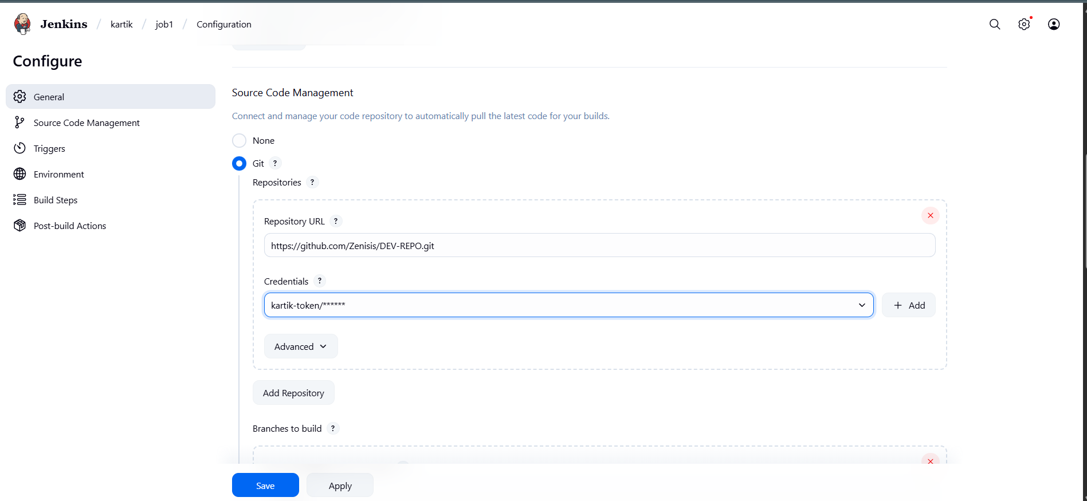

Delete workspace before build and Add build steps using shell

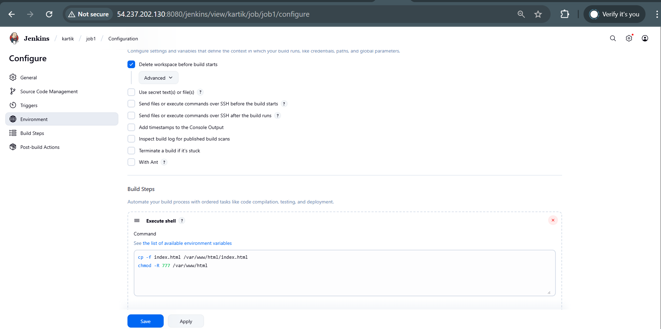

After that save the job . and run the build we will get the output

Repeat same steps for other two jobs

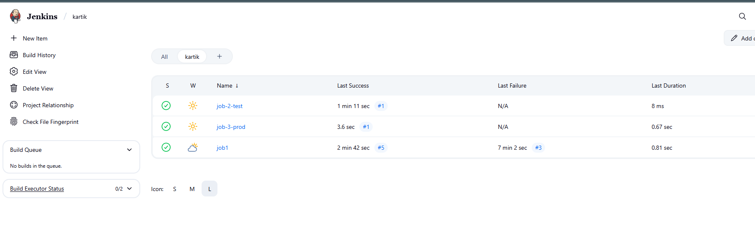

The output will be like this for job1

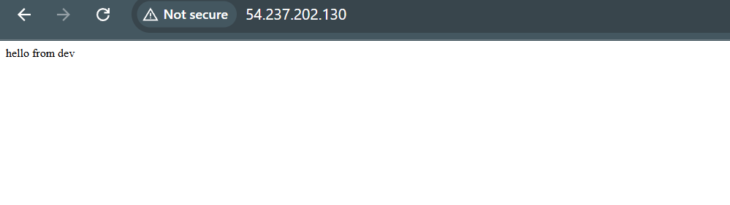

Output from job-2

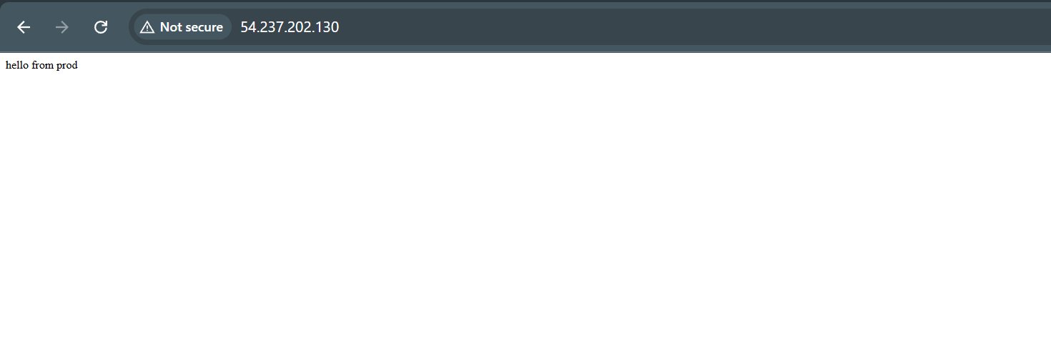

Output from job 3

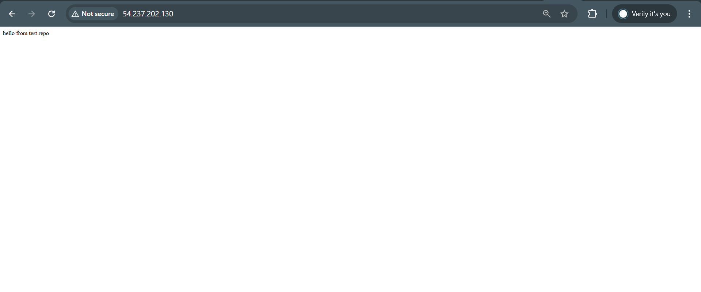

The deployment of 3 jobs of 3 different repos are done